

The Game

S-QUIT Boring Compliance
AIGENTIC COMPLIANCE I INFO@AIGENTICCOMPLIANCE.COM

Game CONcept

Introduction and Context
With this game we are taking compliance training to the next level. And shift the focus to interactive compliance learning through an AI-driven adaptive decision-making experience.
Inspired by the Netflix series Squid Game, this game transforms compliance training into a high-stakes decision-making exercise.

As part of a student challenge, student of the BUAS designed an AI-powered survival challenge where users must navigate compliance scenarios and respond correctly to advance—or face virtual "elimination." This game does not only gamify compliance training but also tests AI’s ability to interpret user responses, provide real-time feedback, and create adaptive learning experiences .

Next step
Now the challenge has been completed for the backend it is time for the game mechanics an user interface.

Game mechanics – proposal

Game Rules:
- The user must answer 5 True/False statements.
- If the user gets a question right, Clau-Hee explains why and moves to the next question.
- If the user gets a question wrong, Clau-Hee provides the correct explanation and ends the chat.
- The difficulty level increases based on performance.
If the user answers 5 correct in a row, they receive a congratulations message.

Level Design
Daria and Viki are working on a 2D platformer pixel style – Super Compliance Sisters in Unity. Therefore we would like to stick with that concept / baseline

MockUp
There's only one screen:
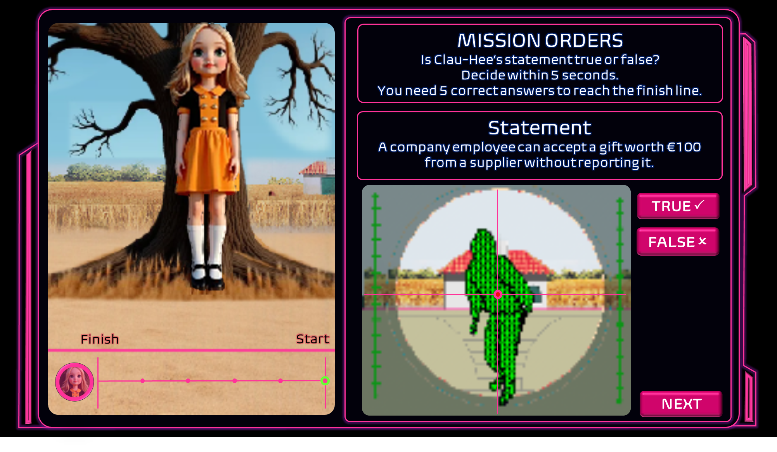
Clauhee faces the player (1/2 of the screen); 1/2 of the screen is a panel on the right divided in 2: Bottom part of the panel: radar view of the player. In the top half the player get's instructions and the statements provided by Clauhee are shown there and the answers/score etc.

I’ve added animations to the silde deck.
- We see clau-hee facing us. We see the player standing relaxed.
- They get instructions
- 3. On you marks, get set go!
- 4. Clauhee turns towards the tree. The player gets into active position and starts running
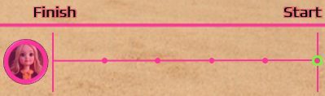
- They can see their progress
- While the question sounds (5 seconds)
- After the 5 seconds Clau-Hee turns around.
- We see the player standing still (rader wheel animation)
- If correct answer; Clauhee says; Correct answer;
- If incorrect answer; we see the player moving a little; Clauhee says; Game over!

Why this setup?
- Single screen, simple logic
- Minimal animation needed (mostly switching between sprite states + a radar-style mini map)
- Clear game flow (7 steps, all based on timed events + condition checks)
- Python-that has been written can be used in backend.

Breakdown of Game Elements
Scene Element | Notes
Clau-Hee sprite facing the player | Static image with animated eyes or blink optional
Player movement radar (dot moving) | Use a simple 2D position on a mini-map canvas
Instruction panel + quiz area | Standard text panel with button input or key press
Clau-Hee turning / audio line | Swap sprite image + play sound file
Countdown timer | Basic timed event in Pygame
Input: True/False answer | Keyboard or on-screen buttons
Game Over trigger / win state | Conditional: wrong answer triggers fail screen

Platform Unity
Suggestion to use Unity for this game as well as the 2D platformer.

Why?
- Consistent visual style (pixel art across both games = cohesive brand/look)
- Shared asset pipeline (sprites, fonts, backgrounds can be reused)
- Reusable UI components in Unity (panels, buttons, etc.)
- Future merge or linking possible (e.g. Squid Game challenge becomes a mini-game inside the 2D platformer)

Unity vs. Python (Pygame) — Key Differences
Feature/Aspect | Unity (C#) | Python (Pygame)
Language | C# (not Python) | Python
Game Engine | Full-featured engine (editor + tools) | Lightweight framework
Visual Tools | Drag & drop UI, sprite animation, prefab system | All manual — mostly code-based
Learning Curve | Steeper for beginners, but standardized | Simpler code, but fewer built-in tools
Pixel Art Support | Excellent with scaling + import system | Manual image loading, no visual editor
Performance & Scalability | Great for full games (platformer, UI, mobile) | Best for prototypes or mini-games
Team Compatibility | ✔️ Matches your other team (V & D) | ❌ Different tech — hard to merge later
Future Reuse | Easy to embed in other Unity games | Difficult or impossible to port

What we developed in Python so far

This python files provided by the students impement a terminal-based compliance game using a language model (LLM). The core features:
- It reads a Word doc containing your compliance policy.
- It uses LangChain and FAISS to create a local semantic search vector database.
- It generates true/false compliance questions about the gift policy using Ollama's LLaMA3 model.
- The player answers questions one by one in the terminal.
- After each answer:
  - If correct: the player moves forward.
  - If wrong: the game ends.
  - After 5 correct answers: the player wins.
- All interactions are logged in a JSON file.

Suggested way forward
Keep Python for the Backend
- Python logic as a backend engine (via API) / Backend serves answers/questions via an API (FastAPI or Flask).
- Add endpoints like: /question, /answer, /score.

We build a UI in Unity or Web

We can purchase an off the shelve UI kit that we can use for both games.
Examples: UIKit 1 UIKit 2 UIKit 3
For the frontend intern (or later Unity dev):
- Build the game screen visuals.
- Hook into Backend API.

